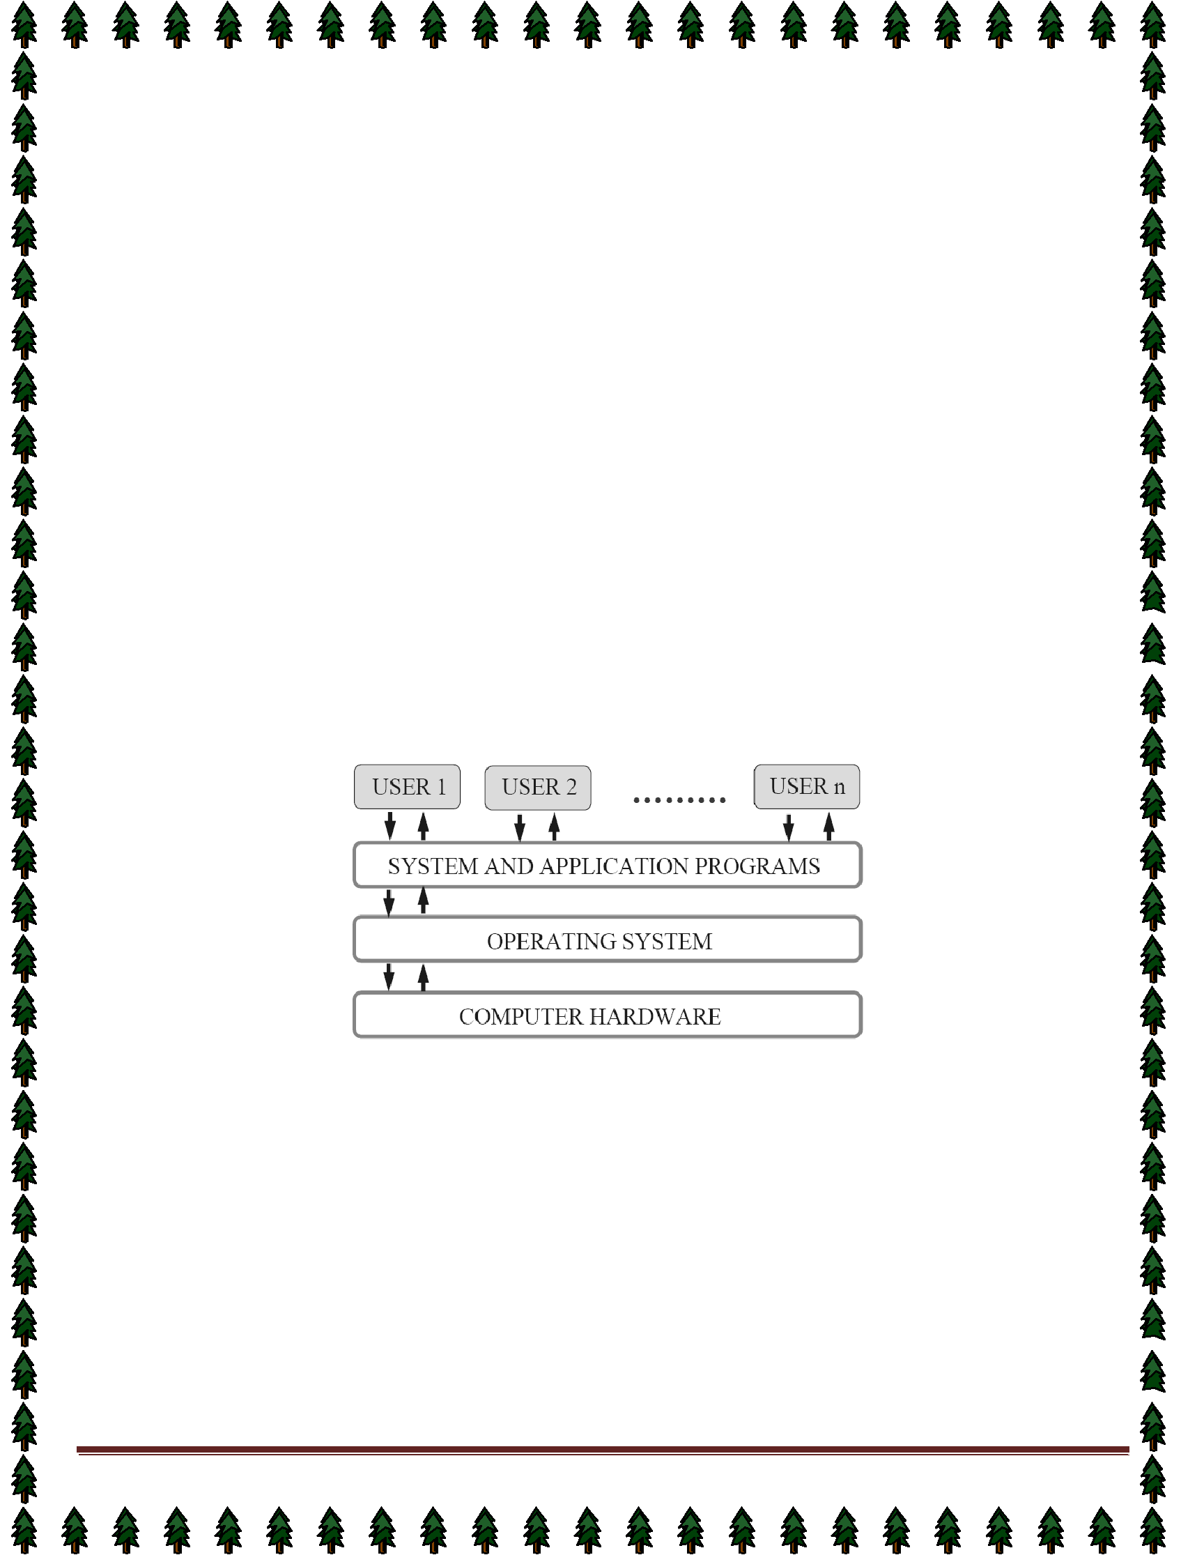
OPERATING SYSTEM

Lecture Notes

Lecture #1

What is an Operating System?

- A program that acts as an intermediary between a user of a computer and the computer hardware.

⇨ An operating System is a collection of system programs that together control the operations of a computer system.

Some examples of operating systems are UNIX, Mach, MS-DOS, MS-Windows, Windows/NT, Chicago, OS/2, MacOS, VMS, MVS, and VM.

Operating system goals:

- Execute user programs and make solving user problems easier.
- Make the computer system convenient to use.
- Use the computer hardware in an efficient manner.
Computer System Components

- Hardware – provides basic computing resources (CPU, memory, I/O devices).

- Operating system – controls and coordinates the use of the hardware among the various application programs for the various users.
- Applications programs – Define the ways in which the system resources are used to solve the computing problems of the users (compilers, database systems, video games, business programs).
4. Users (people, machines, other computers).
Abstract View of System Components

Operating System Definitions

Resource allocator – manages and allocates resources.
Control program – controls the execution of user programs and operations of I/O devices .
Kernel – The one program running at all times (all else being application programs).
Components of OS: OS has two parts. (1)Kernel.(2)Shell.

(1)Kernel is an active part of an OS i.e., it is the part of OS running at all times. It is a programs which can interact with the hardware. Ex: Device driver, dll files, system files etc.

- Shell is called as the command interpreter. It is a set of programs used to interact with the application programs. It is responsible for execution of instructions given to OS (called commands).
Operating systems can be explored from two viewpoints: the user and the system.
User View: From the user’s point view, the OS is designed for one user to monopolize its resources, to maximize the work that the user is performing and for ease of use.  System View: From the computer's point of view, an operating system is a control program that manages the execution of user programs to prevent errors and improper use of the computer. It is concerned with the operation and control of I/O devices.

By Dr. Subhendu Kumar Rath, BPUT Page 2


Lecture #2

Functions of Operating System:

Process Management

A process is a program in execution. A process needs certain resources, including CPU time, memory, files, and I/O devices, to accomplish its task. The operating system is responsible for the following activities in connection with process management.

✦ Process creation and deletion.

✦ process suspension and resumption.

✦ Provision of mechanisms for:

process synchronization
process communication
Main-Memory Management

Memory is a large array of words or bytes, each with its own address. It is a repository of quickly accessible data shared by the CPU and I/O devices.

Main memory is a volatile storage device. It loses its contents in the case of system failure.
The operating system is responsible for the following activities in connections with memory management:
♦ Keep track of which parts of memory are currently being used and by whom.
♦ Decide which processes to load when memory space becomes available.
♦ Allocate and de-allocate memory space as needed.
File Management

A file is a collection of related information defined by its creator. Commonly, files represent programs (both source and object forms) and data.

The operating system is responsible for the following activities in connections with file management:

✦ File creation and deletion.

✦ Directory creation and deletion.

✦ Support of primitives for manipulating files and directories.

✦ Mapping files onto secondary storage.

- File backup on stable (nonvolatile) storage media.

I/O System Management

The I/O system consists of:

- A buffer-caching system

- A general device-driver interface

- Drivers for specific hardware devices

Secondary-Storage Management

Since main memory (primary storage) is volatile and too small to accommodate all data and programs permanently, the computer system must provide secondary storage to back up main memory.

Most modern computer systems use disks as the principle on-line storage medium, for both programs and data.
The operating system is responsible for the following activities in connection with disk management:

- Free space management

- Storage allocation

- Disk scheduling

Networking (Distributed Systems)
♦ A distributed system is a collection processors that do not share memory or a clock. Each processor has
its own local memory.
♦ The processors in the system are connected through a communication network.
♦ Communication takes place using a protocol.
♦ A distributed system provides user access to various system resources.
♦ Access to a shared resource allows: | Page 3
By Dr. Subhendu Kumar Rath, BPUT | Page 3
✦ Computation speed-up


- Increased data availability

✦ Enhanced reliability

♦ Protection refers to a mechanism for controlling access by programs, processes, or users to both
system and user resources.
♦ The protection mechanism must:
✦ distinguish between authorized and unauthorized usage.

✦ specify the controls to be imposed.

✦ provide a means of enforcement.

Command-Interpreter System

Many commands are given to the operating system by control statements which deal with:

✦ process creation and management

✦ I/O handling

✦ secondary-storage management

- main-memory management

✦ file-system access

- protection

- networking

  - The program that reads and interprets control statements is called variously:
- command-line interpreter

- shell (in UNIX)

  - Its function is to get and execute the next command statement.

Operating-System Structures

- System Components
- Operating System Services
- System Calls
- System Programs
- System Structure
- Virtual Machines
- System Design and Implementation
- System Generation

Common System Components

- Process Management
- Main Memory Management
- File Management
- I/O System Management
- Secondary Management
- Networking
- Protection System
- Command-Interpreter System


Lecture #3
Evolution of OS:

1.Mainframe Systems
Reduce setup time by batching similar jobs Automatic job sequencing – automatically transfers control from one
job to another. First rudimentary
operating system. Resident monitor
 initial control in monitor
 control transfers to job

  when job completes control transfers pack to monitor
2. Batch Processing Operating System:
- This type of OS accepts more than one jobs and these jobs are batched/ grouped together according to their similar requirements. This is done by computer operator. Whenever the computer becomes available, the 

batched jobs are sent for execution and gradually the output is sent back to the user.

 It allowed only one program at a time.
 This OS is responsible for scheduling the jobs according to priority and the resource required.

3. Multiprogramming Operating System:

- This type of OS is used to execute more than one jobs simultaneously by a single processor. it increases CPU utilization by organizing jobs so that the CPU always has one job to execute.

- The concept of multiprogramming is described as follows:

  - All the jobs that enter the system are stored in the job pool( in disc). The operating system loads a set of jobs from job pool into main memory and begins to execute.

  - During execution, the job may have to wait for some task, such as an I/O operation, to complete. In a multiprogramming system, the operating system simply switches to another job and executes. When that job needs to wait, the CPU is switched to another job, and so on.
  - When the first job finishes waiting and it gets the CPU back.
  - As long as at least one job needs to execute, the CPU is never idle.
Multiprogramming operating systems use the mechanism of job scheduling and CPU scheduling.
3. Time-Sharing/multitasking Operating Systems

Time sharing (or multitasking) OS is a logical extension of multiprogramming. It provides extra facilities such as:
 Faster switching between multiple jobs to make processing faster.
- Allows multiple users to share computer system simultaneously.
 The users can interact with each job while it is running.

These systems use a concept of virtual memory for effective utilization of memory space. Hence, in this OS, no jobs are discarded. Each one is executed using virtual memory concept. It uses CPU scheduling, memory management, disc management and security management. Examples: CTSS, MULTICS, CAL, UNIX etc.
4. Multiprocessor Operating Systems

Multiprocessor operating systems are also known as parallel OS or tightly coupled OS. Such operating  systems have more than one processor in close communication that sharing the computer bus, the clock and sometimes memory and peripheral devices. It executes multiple jobs at same time and makes the processing faster. Multiprocessor systems have three main advantages:
- Increased throughput: By increasing the number of processors, the system performs more work in less time.

The speed-up ratio with N processors is less than N.
- Economy of scale: Multiprocessor systems can save more money than multiple single-processor systems,
because they can share peripherals, mass storage, and power supplies.

- Increased reliability: If one processor fails to done its task, then each of the remaining processors must pick

up a share of the work of the failed processor. The failure of one processor will not halt the system, only slow it down.

The ability to continue providing service proportional to the level of surviving hardware is called graceful degradationByDr.Subhendu.SystemsKumardesignedRath,for BPUTgraceful degradation are called fault tolerant. Page 5 


The multiprocessor operating systems are classified into two categories:
- Symmetric multiprocessing system
2. Asymmetric multiprocessing system
- In symmetric multiprocessing system, each processor runs an identical copy of the operating system, and
these copies communicate with one another as needed.
- In asymmetric multiprocessing system, a processor is called master processor that controls other processors
called slave processor. Thus, it establishes master-slave relationship. The master processor schedules the jobs and manages the memory for entire system.

5. Distributed Operating Systems

- In distributed system, the different machines are connected in a network and each machine has its own
processor and own local memory.
- In this system, the operating systems on all the machines work together to manage the collective network
resource.
 It can be classified into two categories:
1. Client-Server systems
2. Peer-to-Peer systems
Advantages of distributed systems.

 Resources Sharing
 Computation speed up – load sharing
 Reliability
 Communications

 Requires networking infrastructure.
 Local area networks (LAN) or Wide area networks (WAN)
.
6. Desktop Systems/Personal Computer Systems

- The PC operating system is designed for maximizing user convenience and responsiveness. This system is
neither multi-user nor multitasking.

- These systems include PCs running Microsoft Windows and the Apple Macintosh. The MS-DOS operating system from Microsoft has been superseded by multiple flavors of Microsoft Windows and IBM has upgraded MS-DOS to the OS/2 multitasking system.
- The Apple Macintosh operating system has been ported to more advanced hardware, and now includes new

features such as virtual memory and multitasking.

- A real-time operating system (RTOS) is a multitasking operating system intended for applications with fixed
deadlines (real-time computing). Such applications include some small embedded systems, automobile engine controllers, industrial robots, spacecraft, industrial control, and some large-scale computing systems.
 The real time operating system can be classified into two categories:
1. hard real time system and 2. soft real time system.
- A hard real-time system guarantees that critical tasks be completed on time. This goal requires that all delays in the system be bounded, from the retrieval of stored data to the time that it takes the operating  system to finish any request made of it. Such time constraints dictate the facilities that are available in hard
real-time systems.
- A soft real-time system is a less restrictive type of real-time system. Here, a critical real-time task gets

priority over other tasks and retains that priority until it completes. Soft real time system can be mixed with other types of systems. Due to less restriction, they are risky to use for industrial control and robotics.


Lecture #4

Operating System Services

Following are the five services provided by operating systems to the convenience of the users.
1. Program Execution

The purpose of computer systems is to allow the user to execute programs. So the operating system provides an environment where the user can conveniently run programs. Running a program involves the  allocating and deallocating memory, CPU scheduling in case of multiprocessing. 2. I/O Operations

Each program requires an input and produces output. This involves the use of I/O. So the operating systems are providing I/O makes it convenient for the users to run programs.

3. File System Manipulation The output of a program may need to be written into new files or input taken from some files. The
operating system provides this service.

4. Communications

The processes need to communicate with each other to exchange information during execution. It may be between processes running on the same computer or running on the different computers. Communications can be occur in two ways: (i) shared memory or (ii) message passing 5. Error Detection

An error is one part of the system may cause malfunctioning of the complete system. To avoid such a situation operating system constantly monitors the system for detecting the errors. This relieves the user of the worry of errors propagating to various part of the system and causing malfunctioning.

Following are the three services provided by operating systems for ensuring the efficient operation of the system itself. 1. Resource allocation

When multiple users are logged on the system or multiple jobs are running at the same time, resources must be allocated to each of them. Many different types of resources are managed by the operating system.

2. Accounting

The operating systems keep track of which users use how many and which kinds of computer resources. This record keeping may be used for accounting (so that users can be billed) or simply for accumulating usage statistics.

3. Protection

When several disjointed processes execute concurrently, it should not be possible for one process to interfere with the others, or with the operating system itself. Protection involves ensuring that all access to system resources is controlled. Security of the system from outsiders is also important. Such security starts with each user having to authenticate him to the system, usually by means of a password, to be allowed access to the resources. 

System Call:

- System calls provide an interface between the process and the operating system.

- System calls allow user-level processes to request some services from the operating system which process itself is not allowed to do.
➢ | For example, for I/O a process involves a system call telling the operating system to read or write particular
 | area and this request is satisfied by the operating system.
 | The following different types of system calls provided by an operating system:
 |  | create process, terminate process
Process control |  | get process attributes, set process attributes
 |  |  | wait for time
 | end, abort |  | wait for time
 | end, abort |  | wait event, signal event
By Dr. Subhendu Kumar Rath, BPUT |  |  | wait event, signal event | Page 7
 | load, execute |  | allocate and free memory

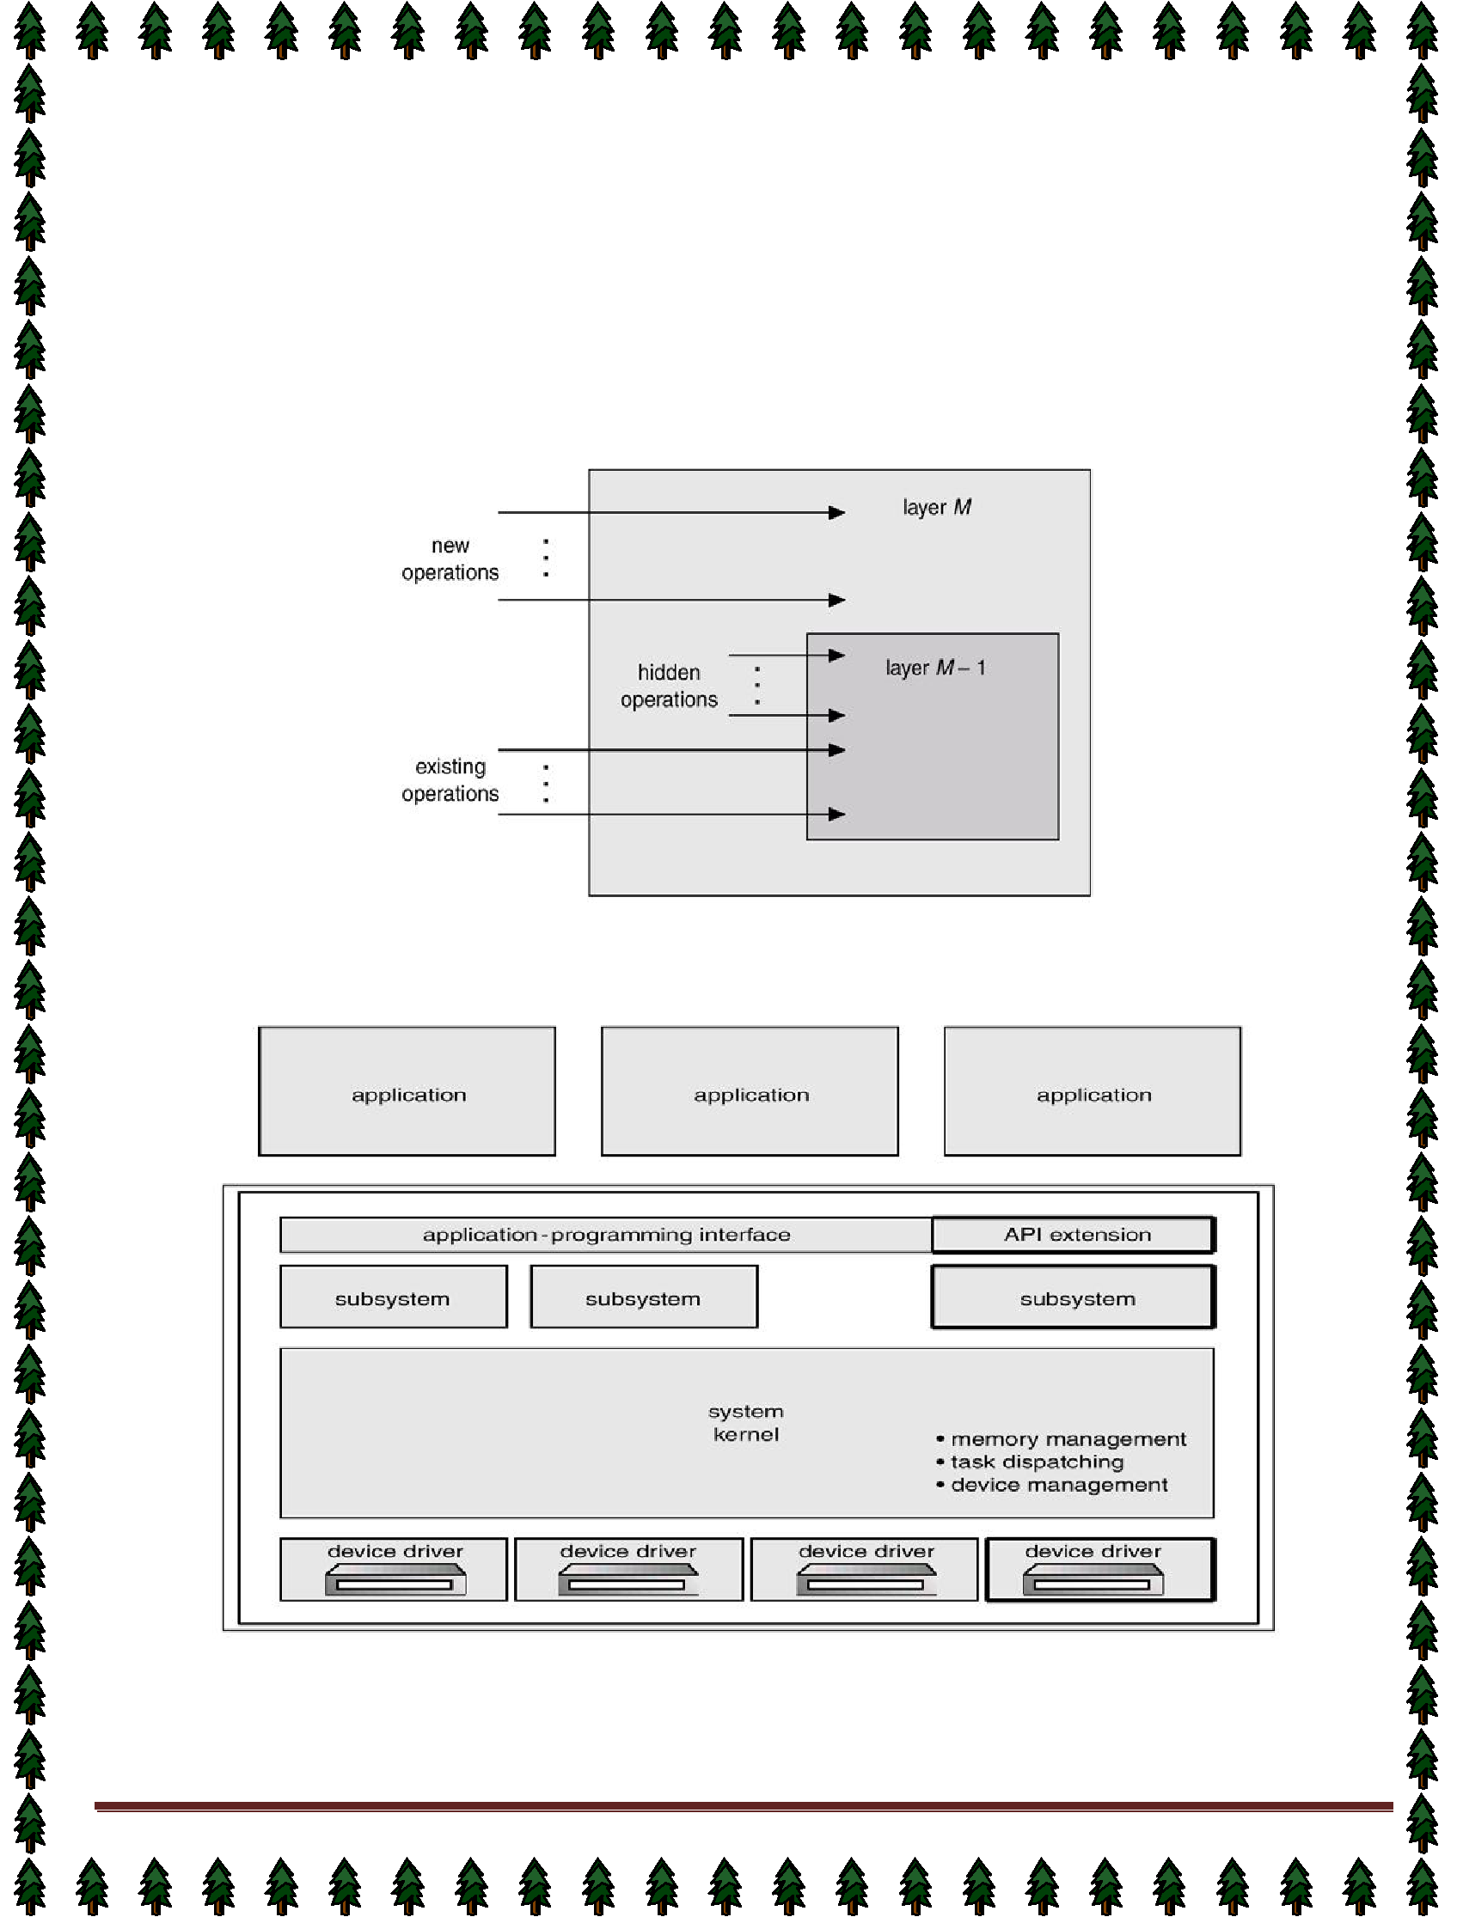
File management |  |  |  |  | Information maintenance
create file, delete file |  |  |  |  | get time or date, set |  |  | time or date
 | open, close |  |  |  | get system data, set system data
 | read, write, reposition |  |  |  | get process, file, or device attributes
get file attributes, set file attributes |  |  |  |  | set process, file, or device attributes
Device management |  |  |  |  | Communications
request device, |  |  | release device |  | create, delete |  | communication connection
 | read, write, reposition |  |  |  |  | send, receive messages
get device attributes, set device attributes |  |  |  |  |  | transfer status information
logically attach or detach devices |  |  |  | attach or detach remote devices

An Operating System Layer

OS/2 Layer Structure

Microkernel System Structure
Moves as much from the kernel into “user” space.
Communication takes place between user modules using message passing. | Page 8
By Dr. Subhendu Kumar Rath, BPUT | Page 8
Benefits:

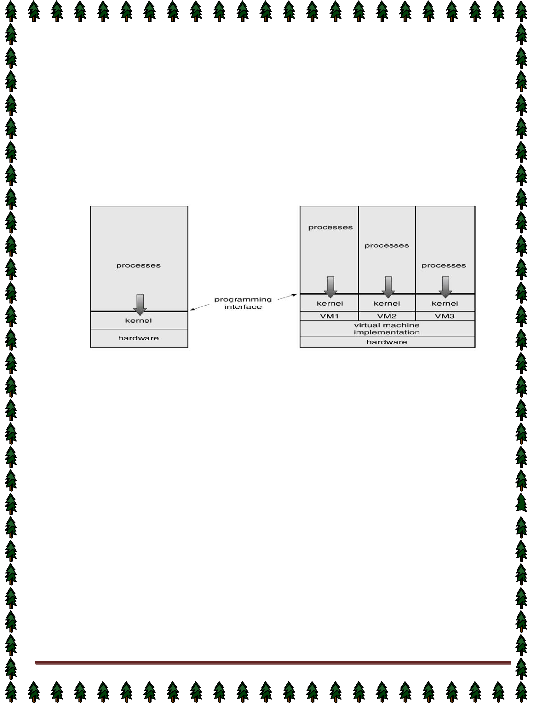
easier to extend a microkernel
easier to port the operating system to new architectures
more reliable (less code is running in kernel mode)
more secure
Virtual Machines

- A virtual machine takes the layered approach to its logical conclusion. It treats hardware and the operating system kernel as though they were all hardware.
A virtual machine provides an interface identical to the underlying bare hardware.
- The operating system creates the illusion of multiple processes, each executing on its own processor

with its own (virtual) memory.

The resources of the physical computer are shared to create the virtual machines.

✦ CPU scheduling can create the appearance that users have their own processor.

✦ Spooling and a file system can provide virtual card readers and virtual line printers.

✦ A normal user time-sharing terminal serves as the virtual machine operator’s console.

System Models

Non-virtual Machine Virtual Machine

- Advantages/Disadvantages of Virtual Machines

- The virtual-machine concept provides complete protection of system resources since each virtual
- machine is isolated from all other virtual machines. This isolation, however, permits no direct sharing of resources.

- A virtual-machine system is a perfect vehicle for operating-systems research and development. System development is done on the virtual machine, instead of on a physical machine and so does not disrupt normal system operation.
- The virtual machine concept is difficult to implement due to the effort required to provide an exact duplicate to the underlying machine.

System Generation (SYSGEN)
Operating systems are designed to run on any of a class of machines at a variety of sites with a variety of peripheral configurations. The system must then be configured or generated for each specific computer site, a process sometimes known as system generation (SYSGEN).
SYSGEN program obtains information concerning the specific configuration of the hardware system.
To generate a system, we use a special program. The SYSGEN program reads from a given file, or asks the operator of the system for information concerning the specific configuration of the hardware system, or probes the hardware directly to determine what components are there.

The following kinds of information must be determined.
What CPU will be used? What options (extended instruction sets, floating point arithmetic, and so on) are installed? For multiple-CPU systems, each CPU must be described.

How much memory is available? Some systems will determine this value themselves by referencing memory location after memory location until an "illegal address" fault is generated. This procedure defines the final legal address and hence the amount of available memory.

What devices are available? The system will need to know how to address each device (the device number), the device interrupt number, the device's type and model, and any special device characteristics.

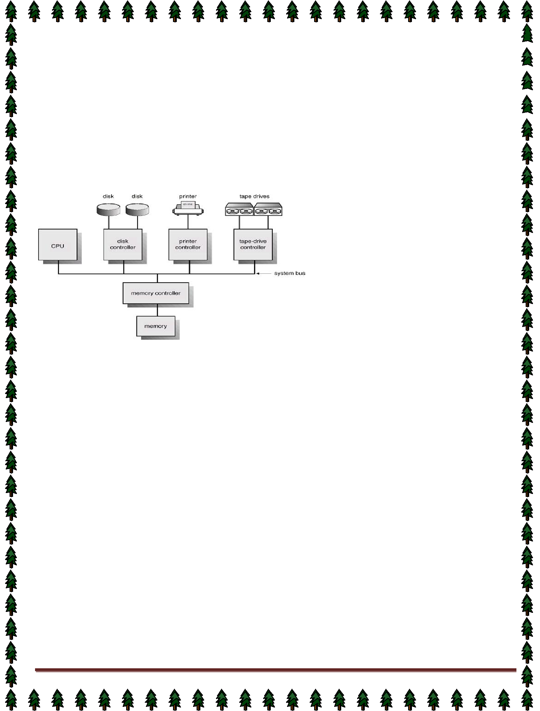
What operating-system options are desired, or what parameter values are to be used? These options or values  might include how many buffers of which sizes should be used, what type of CPU-scheduling algorithm is desired, what the maximum number of processes to be supported is.

Booting –The procedure of starting a computer by loading the kernel is known as booting the system. Most computer systems have a small piece of code, stored in ROM, known as the bootstrap program or bootstrap loader. This code is able to locate the kernel, load it into main memory, and start its execution. Some computer systems, such as PCs, use a two-step process in which a simple bootstrap loader fetches a more complex boot program from disk, which in turn loads the kernel.

Lecture #5

Computer-System Architecture

Computer-System Operation

- I/O devices and the CPU can execute concurrently.
- Each device controller is in charge of a particular device type.
- Each device controller has a local buffer.
- CPU moves data from/to main memory to/from local buffers
- I/O is from the device to local buffer of controller.
- Device controller informs CPU that it has finished its operation by causing an interrupt.
Common Functions of Interrupts

- Interrupt transfers control to the interrupt service routine generally, through the interrupt vector, which contains the addresses of all the service routines.
Interrupt architecture must save the address of the interrupted instruction.

- Incoming interrupts are disabled while another interrupt is being processed to prevent a lost interrupt.
A trap is a software-generated interrupt caused either by an error or a user request.

- An operating system is interrupt driven.

Interrupt Handling

- The operating system preserves the state of the CPU by storing registers and the program counter.
Determines which type of interrupt has occurred: polling, vectored interrupt system
- Separate segments of code determine what action should be taken for each type of interrupt

Interrupt Time Line For a Single Process Doing Output

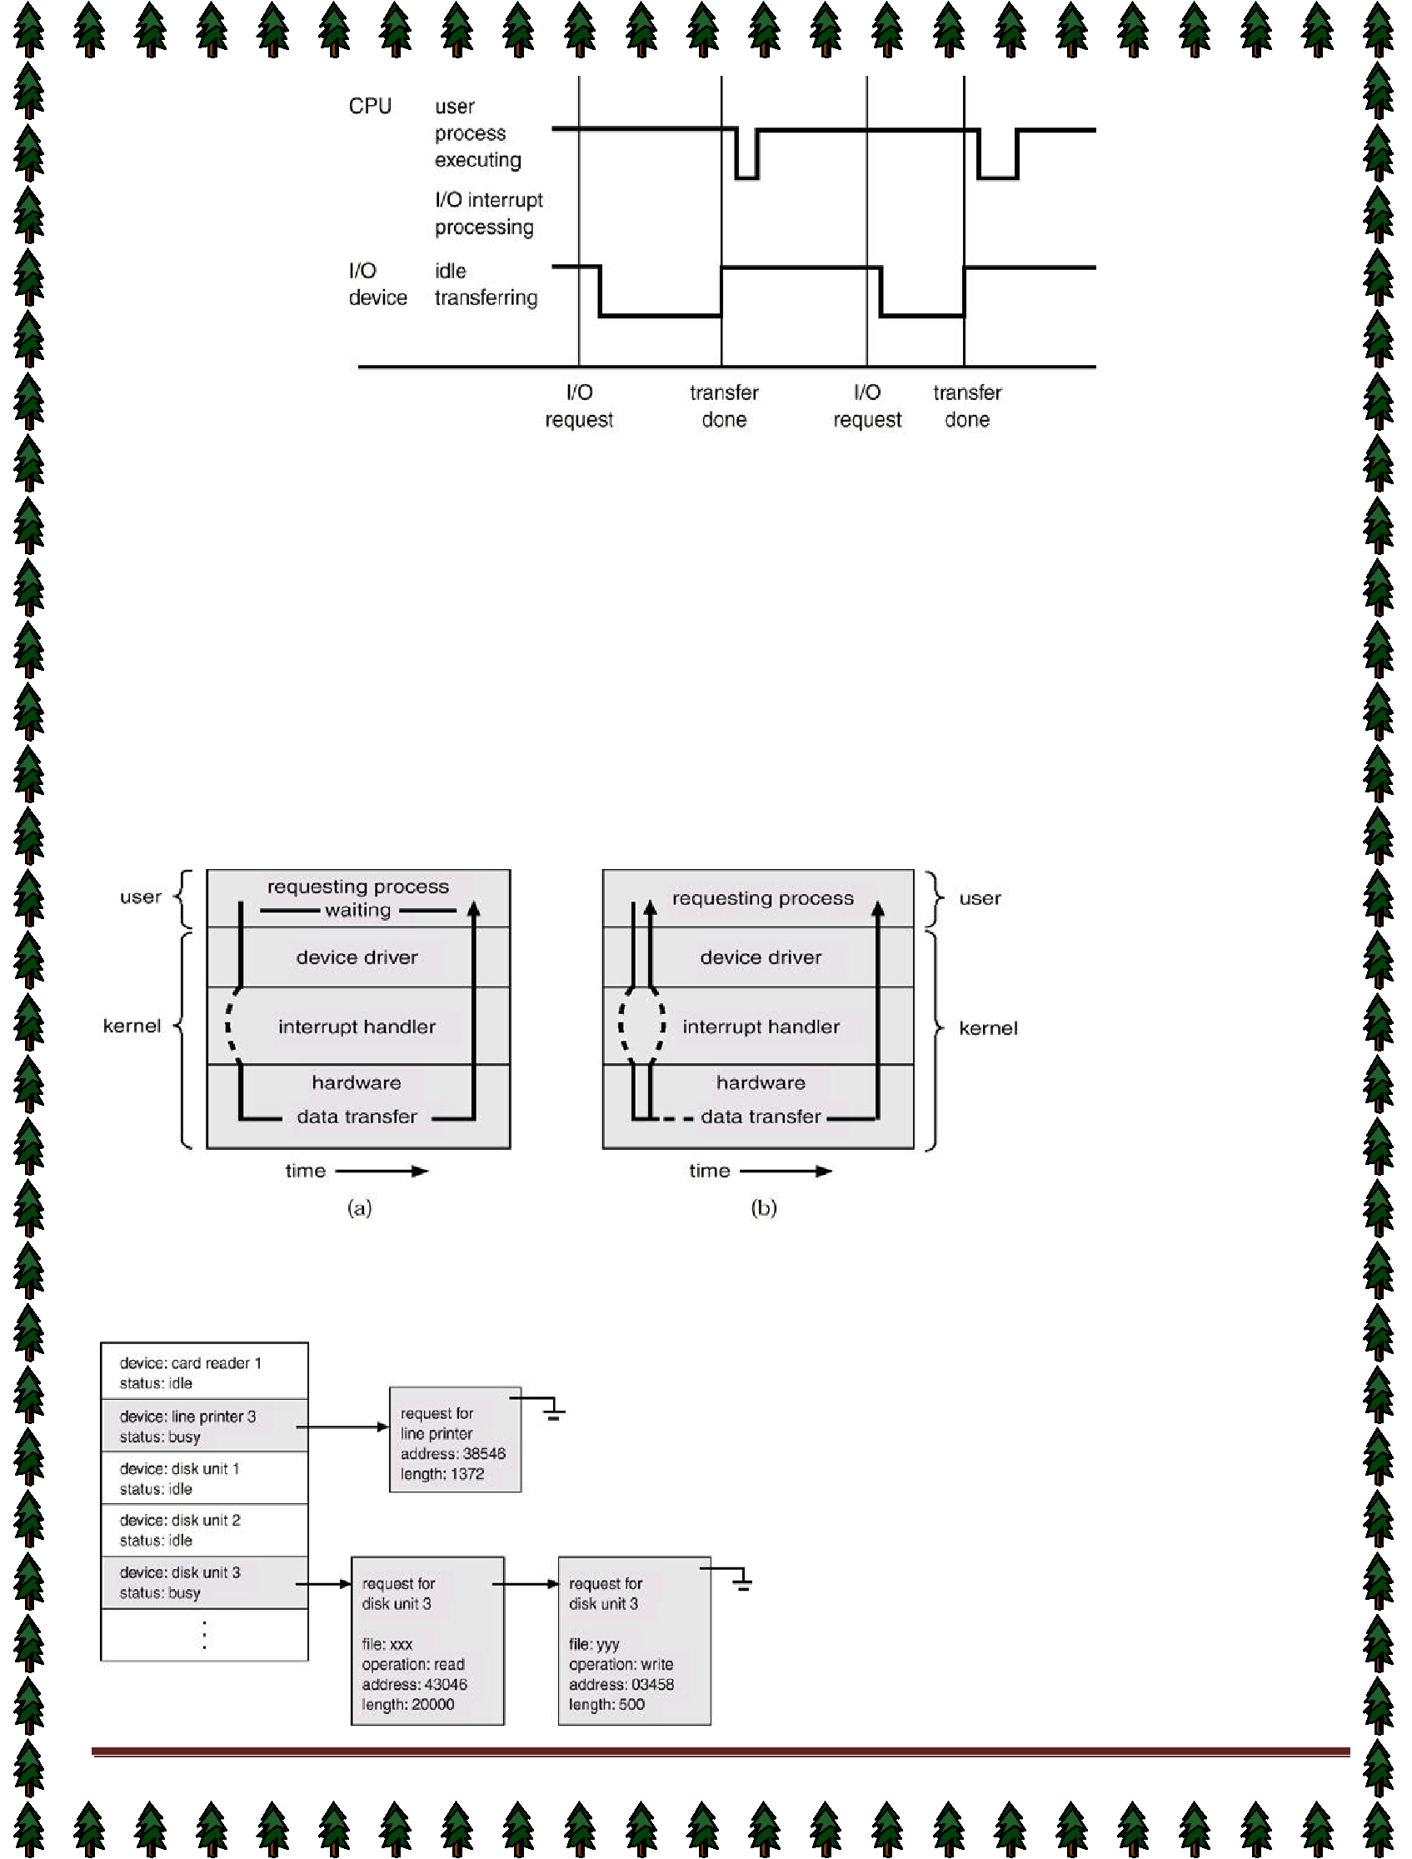

I/O Structure

After I/O starts, control returns to user program only upon I/O completion.

✦ Wait instruction idles the CPU until the next interrupt

- Wait loop (contention for memory access).

✦ At most one I/O request is outstanding at a time, no simultaneous I/O processing.

After I/O starts, control returns to user program without waiting for I/O completion.

✦ System call – request to the operating system to allow user to wait for I/O completion.

- Device-status table contains entry for each I/O device indicating its type, address, and state.

- Operating system indexes into I/O device table to determine device status and to modify table entry to include interrupt.

Two I/O Methods

Synchronous Asynchronous

Device-Status Table

Page 11


Direct Memory Access Structure

- Used for high-speed I/O devices able to transmit information at close to memory speeds.
- Device controller transfers blocks of data from buffer storage directly to main memory without CPU intervention.

- Only on interrupt is generated per block, rather than the one interrupt per byte.

Storage Structure

Main memory – only large storage media that the CPU can access directly.
Secondary storage – extension of main memory that provides large nonvolatile storage capacity. Magnetic disks – rigid metal or glass platters covered with magnetic recording material
- Disk surface is logically divided into tracks, which are subdivided into sectors.

- The disk controller determines the logical interaction between the device and the computer.

Storage Hierarchy

Storage systems organized in hierarchy.

✦ Speed

✦ Cost
✦ Volatility Caching – copying information into faster storage system; main memory can be viewed as a last cache for  secondary storage.

Use of high-speed memory to hold recently-accessed data.
Requires a cache management policy.

- Caching introduces another level in storage hierarchy.
This requires data that is simultaneously stored in more than one level to be consistent.

Storage-Device Hierarchy

Hardware Protection
Dual-Mode Operation | Page 12


I/O Protection
Memory Protection
CPU Protection
Dual-Mode Operation

- Sharing system resources requires operating system to ensure that an incorrect program cannot cause
other programs to execute incorrectly.

- Provide hardware support to differentiate between at least two modes of operations.
User mode – execution done on behalf of a user.

- Monitor mode (also kernel mode or system mode) – execution done on behalf of operating system.
Mode bit added to computer hardware to indicate the current mode: monitor (0) or user (1).
- When an interrupt or fault occurs hardware switches to Privileged instructions can be issued only in
monitor mode.
monitor user ,Interrupt/fault ,set user mode

I/O Protection

- All I/O instructions are privileged instructions.
- Must ensure that a user program could never gain control of the computer in monitor mode (I.e.a user program that, as part of its execution, stores a new address in the

interrupt vector).

Memory Protection
Must provide memory protection at least for the interrupt vector and the interrupt service routines.

- In order to have memory protection, add two registers that determine the range of legal addresses a program may access:

✦ Base register – holds the smallest legal physical memory address.

✦ Limit register – contains the size of the range

Memory outside the defined range is protected.

- When executing in monitor mode, the operating system has unrestricted access to both monitor and user’s memory.
The load instructions for the base and limit registers are privileged instructions.

Timer – interrupts computer after specified period to ensure operating system maintains control.

- Timer is decremented every clock tick.

✦ When timer reaches the value 0, an interrupt occurs.

- Timer commonly used to implement time sharing.
Time also used to compute the current time.

Load-timer is a privileged instruction.

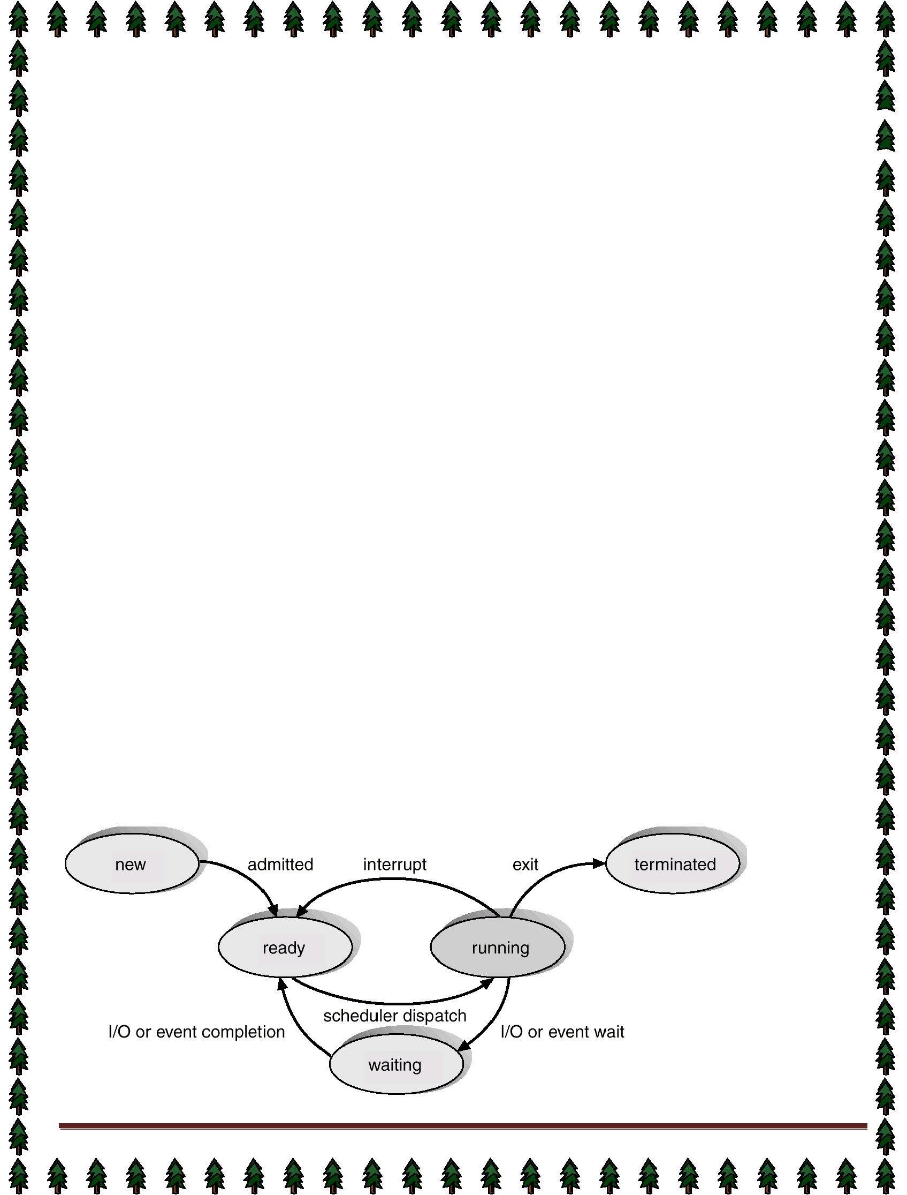
Lecture #6

Process Concept

- Informally, a process is a program in execution. A process is more than the program code, which is sometimes known as the text section. It also includes the current activity, as represented by the value of
the program counter and the contents of the processor's registers. In addition, a process generally
includes the process stack, which contains temporary data (such as method parameters, return addresses, and local variables), and a data section, which contains global variables.

- An operating system executes a variety of programs:

✦ Batch system – jobs

- Time-shared systems – user programs or tasks

Process – a program in execution; process execution must progress in sequential fashion.
- A process includes: program counter , stack, data section
Process State

As a process executes, it changes state

- New State: The process is being created.
 Running State: A process is said to be running if it has the CPU, that is, process actually using the CPU at that particular instant.

- Blocked (or waiting) State: A process is said to be blocked if it is waiting for some event to happen such that as an I/O completion before it can proceed. Note that a process is unable to run until some external event happens.

- Ready State: A process is said to be ready if it needs a CPU to execute. A ready state process is runnable

but temporarily stopped running to let another process run.
 Terminated state: The process has finished execution.

What is the difference between process and program?

1) Both are same beast with different name or when this beast is sleeping (not executing) it is called program and when it is executing becomes process.

- Program is a static object whereas a process is a dynamic object.
- A program resides in secondary storage whereas a process resides in main memory.
- The span time of a program is unlimited but the span time of a process is limited.
- A process is an 'active' entity whereas a program is a 'passive' entity.
- A program is an algorithm expressed in programming language whereas a process is expressed in assembly language or machine language.

Diagram of Process State

Page 14

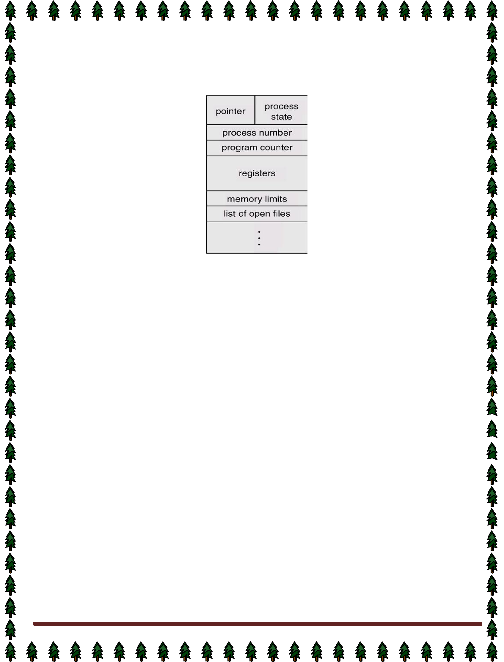
Lecture #7,#8

Process Control Block (PCB)

Information associated with each process.

Process state
Program counter
- CPU registers
CPU scheduling information
- Memory-management information
Accounting information
- I/O status information
Process state: The state may be new, ready, running, waiting, halted, and SO on.

Program counter: The counter indicates the address of the next instruction to be executed for this process.
CPU registers: The registers vary in number and type, depending on the computer architecture. They include accumulators, index registers, stack pointers, and general-purpose registers, plus any condition-code information. Along with the program counter, this state information must be saved when an interrupt occurs, to allow the process to be continued correctly afterward.

CPU-scheduling information: This information includes a process priority, pointers to scheduling queues, and

any other scheduling parameters.
Memory-management information: This information may include such information as the value of the base and

limit registers, the page tables, or the segment tables, depending on the memory system used by the operating
system.
Accounting information: This information includes the amount of CPU and real time used, time limits, account numbers, job or process numbers, and so on.

status information: The information includes the list of I/O devices allocated to this process, a list of open files, and so on.
The PCB simply serves as the repository for any information that may vary from process to process.

Process Scheduling Queues

➲ Job Queue: This queue consists of all processes in the system; those processes are entered to the system as new processes.

➲ Ready Queue: This queue consists of the processes that are residing in main memory and are ready and waiting to execute by CPU. This queue is generally stored as a linked list. A ready-queue header contains pointers to the first and final PCBs in the list. Each PCB includes a pointer field that points to the next PCB in the ready queue.

 Device Queue: This queue consists of the processes that are waiting for a particular I/O device. Each
device has its own device queue. | Page 15


Representation of Process Scheduling
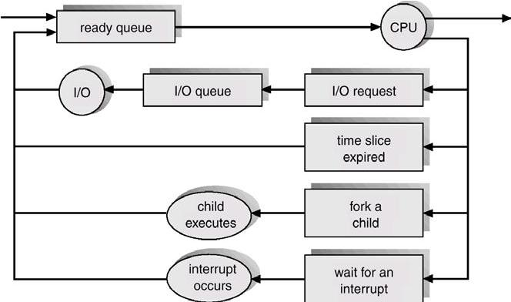

Schedulers

A scheduler is a decision maker that selects the processes from one scheduling queue to another or allocates CPU for execution. The Operating System has three types of scheduler:

1. Long-term scheduler or Job scheduler
2. Short-term scheduler or CPU scheduler
3. Medium-term scheduler

Long-term scheduler or Job scheduler

- The long-term scheduler or job scheduler selects processes from discs and loads them into main memory for execution. It executes much less frequently.
- It controls the degree of multiprogramming (i.e., the number of processes in memory).
- Because of the longer interval between executions, the long-term scheduler can afford to take more time to
select a process for execution.

Short-term scheduler or CPU scheduler

- The short-term scheduler or CPU scheduler selects a process from among the processes that are ready to
execute and allocates the CPU.
- The short-term scheduler must select a new process for the CPU frequently. A process may execute for only
a few milliseconds before waiting for an I/O request.

Medium-term scheduler

The medium-term scheduler schedules the processes as intermediate level of scheduling
Processes can be described as either:
✦ I/O-bound process – spends more time doing I/O than computations, many short CPU bursts.

✦ CPU-bound process – spends more time doing computations; few very long CPU bursts.

Context Switch

- When CPU switches to another process, the system must save the state of the old process and load the  saved state for the new process.

By Dr. Subhendu Kumar Rath, BPUT |  | Page 16
 | Context-switch time is overhead; the system does no useful work while switching.




Time dependent on hardware support.

Process Creation

Parent process create children processes, which, in turn create other processes, forming a tree of processes.

Resource sharing:✦ Parent and children share all resources.

- Children share subset of parent’s resources.

✦ Parent and child share no resources.

Execution: ✦ Parent and children execute concurrently.

✦ Parent waits until children terminate.

Address space: ✦ Child duplicate of parent.

✦ Child has a program loaded into it.

UNIX examples

- fork system call creates new process

- exec system call used after a fork to replace the process’ memory space with a new program.

Process Termination

  - Process executes last statement and asks the operating system to decide it (exit).

- Output data from child to parent (via wait).

- Process’ resources are deallocated by operating system.

  - Parent may terminate execution of children processes (abort).

- Child has exceeded allocated resources.

- Task assigned to child is no longer required.

✦ Parent is exiting.

- Operating system does not allow child to continue if its parent terminates.

✔ Cascading termination.

Cooperating Processes

The concurrent processes executing in the operating system may be either independent processes or cooperating processes. A process is independent if it cannot affect or be affected by the other processes

executing in the system. Clearly, any process that does not share any data (temporary or persistent) with any other process is independent. On the other hand, a process is cooperating if it can affect or be affected by the

other processes executing in the system. Clearly, any process that shares data with other processes is a cooperating process.

Advantages of process cooperation

Information sharing: Since several users may be interested in the same piece of information (for instance, a shared file), we must provide an environment to allow concurrent access to these types of resources.

Computation speedup: If we want a particular task to run faster, we must break it into subtasks, each of which will be executing in parallel with the others. Such a speedup can be achieved only if the computer has multiple processing elements (such as CPUS or I/O channels). Modularity: We may want to construct the system in a modular fashion, dividing the system functions into separate processes or threads Convenience: Even an individual user may have many tasks on which to work at one time. For instance, a user may be editing, printing, and compiling in parallel.

Concurrent execution of cooperating processes requires mechanisms that allow processes to communicate with one another and to synchronize their actions.

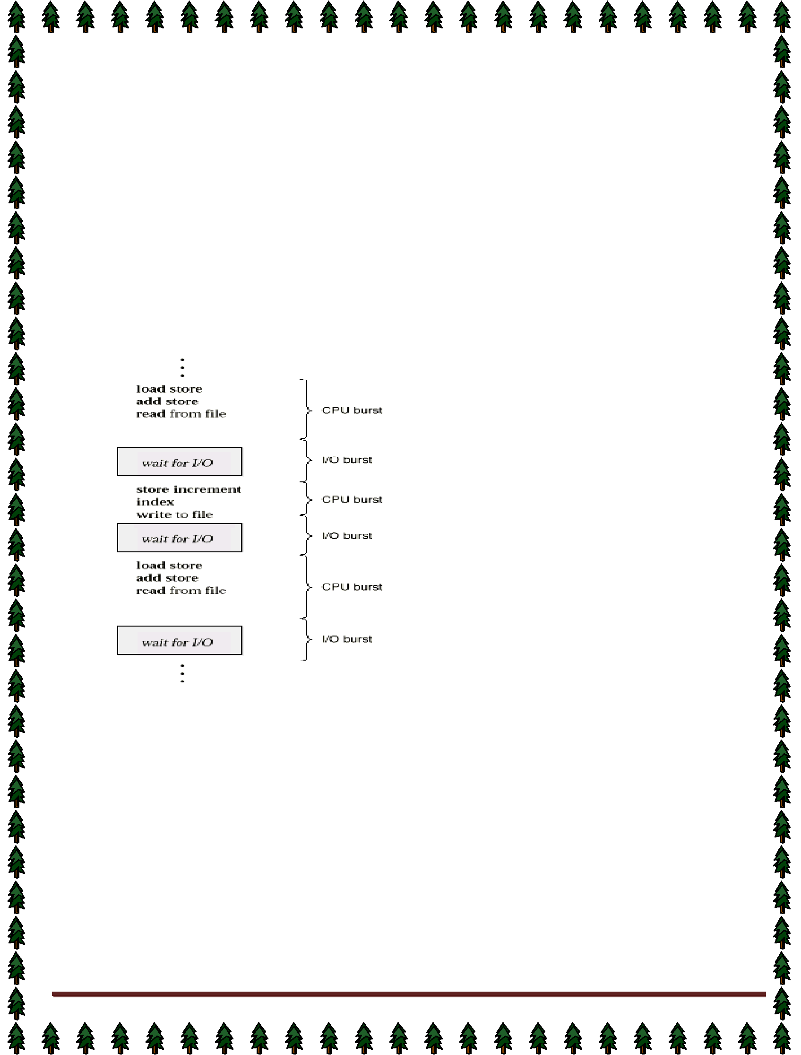
Lecture #9,#10,#11,#12

CPU Scheduling

Basic Concepts

- Scheduling Criteria

- Multiple-Processor Scheduling

- Algorithm Evaluation
Basic Concepts

Maximum CPU utilization obtained with multiprogramming

- CPU–I/O Burst Cycle – Process execution consists of a cycle of CPU execution and I/O wait.
CPU burst distribution

Alternating Sequence of CPU And I/O Bursts

CPU Scheduler

- Selects from among the processes in memory that are ready to execute, and allocates the CPU to one of them.

- CPU scheduling decisions may take place when a process:
  - Switches from running to waiting state.
  - Switches from running to ready state.
3. Switches from waiting to ready.
4. Terminates.

Scheduling under 1 and 4 is non preemptive.
All other scheduling is preemptive.

Dispatcher

Dispatcher module gives control of the CPU to the process selected by the short-term scheduler; this
involves:
✦ switching context | Page 18
By Dr. Subhendu Kumar Rath, BPUT | Page 18

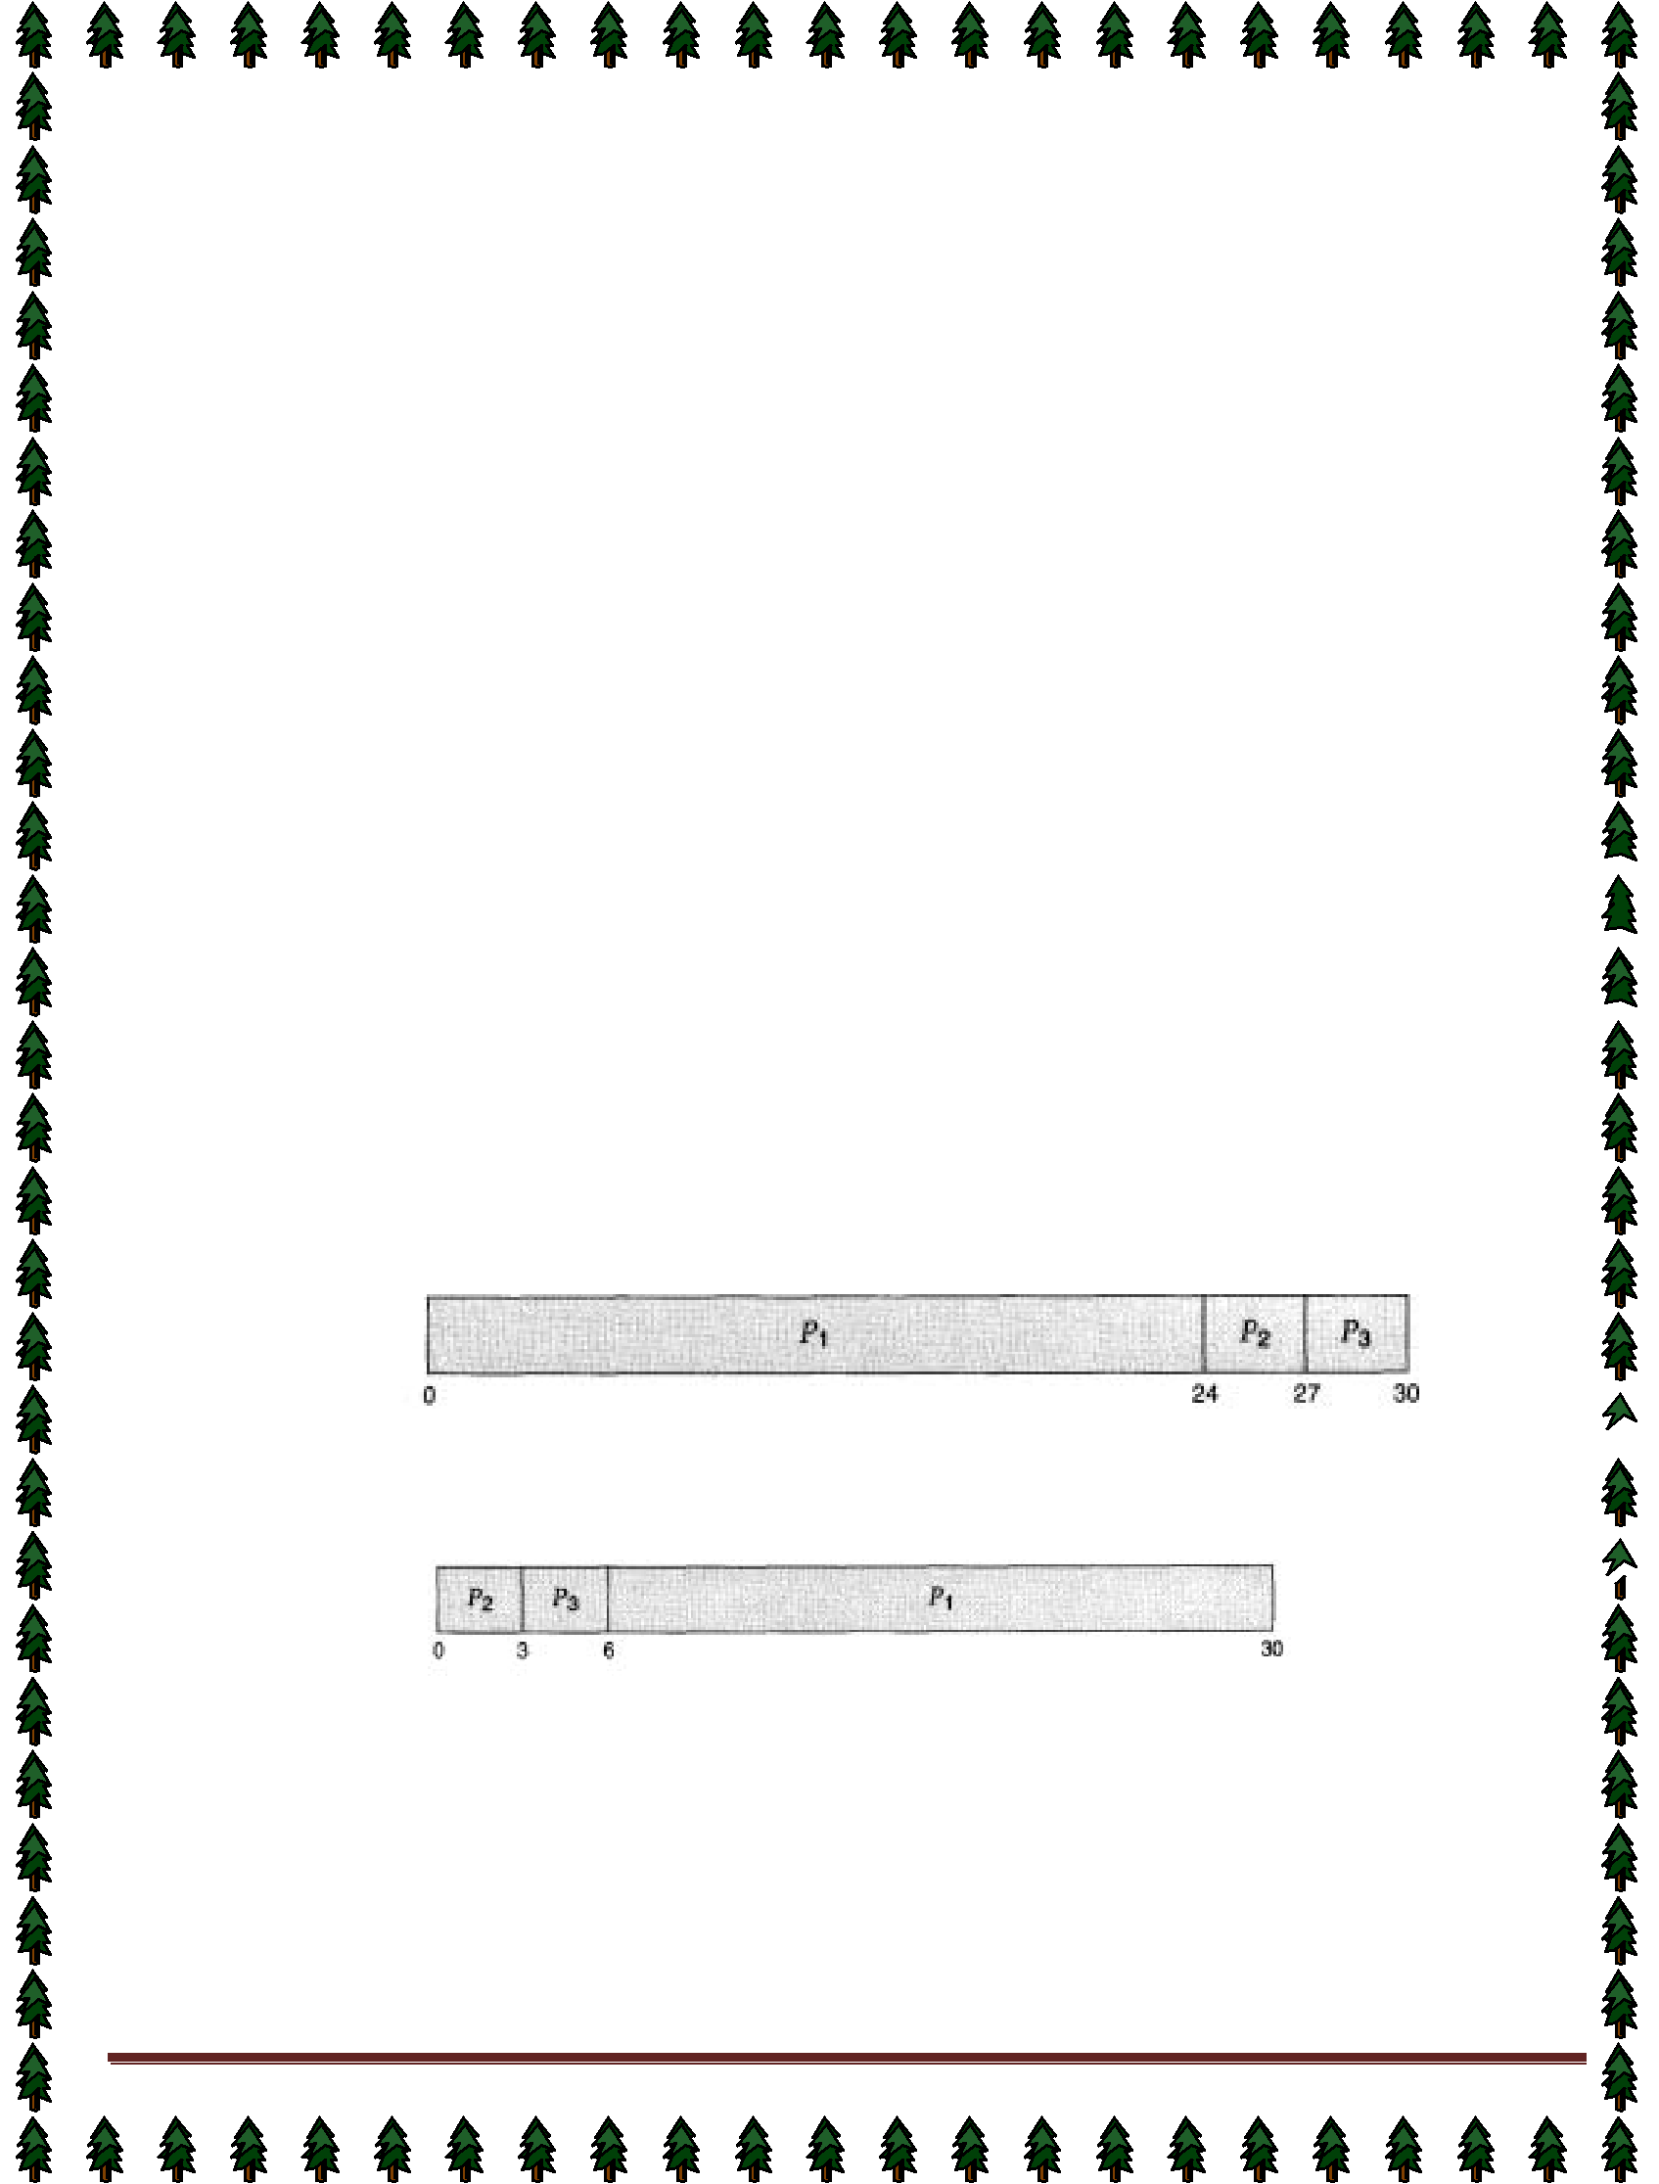
✦ switching to user mode

✦ jumping to the proper location in the user program to restart that program
Dispatch latency – time it takes for the dispatcher to stop one process and start another running.

Scheduling Criteria

- CPU utilization – keep the CPU as busy as possible
- Throughput – # of processes that complete their execution per time unit
- Turnaround time – amount of time to execute a particular process
- Waiting time – amount of time a process has been waiting in the ready queue
- Response time – amount of time it takes from when a request was submitted until the first response is produced, not output (for time-sharing environment)

Optimization Criteria

- Max CPU utilization
- Max throughput
- Min turnaround time
- Min waiting time
Min response time

First-Come, First-Served Scheduling

By far the simplest CPU-scheduling algorithm is the first-come, first-served (FCFS) scheduling algorithm. With this scheme, the process that requests the CPU first is allocated the CPU first. The implementation of the  FCFS policy is easily managed with a FIFO queue. When a process enters the ready queue, its PCB is linked onto the tail of the queue. When the CPU is free, it is allocated to the process at the head of the queue. The running process is then removed from the queue. The code for FCFS scheduling is simple to write and understand. The average waiting time under the FCFS policy, however, is often quite long.

Consider the following set of processes that arrive at time 0, with the length of the CPU-burst time given
in milliseconds:
Process | Burst Time
PI | 24
P2 | 3
P3 | 3
If the processes arrive in the order PI, P2, P3, and are served in FCFS order, we get the result shown in the

following Gantt chart:  The waiting time is 0 milliseconds for process PI, 24 milliseconds for process PZ, and 27 milliseconds for process P3. Thus, the average waiting time is (0 + 24 + 27)/3 = 17 milliseconds. If the processes arrive in the order P2, P3, Pl, however, the results will be as shown in the following Gantt chart: 

The average waiting time is now (6 + 0 + 3)/3 = 3 milliseconds. This reduction is substantial. Thus, the average waiting time under a FCFS policy is generally not minimal, and may vary substantially if the process CPU-burst times vary greatly.

In addition, consider the performance of FCFS scheduling in a dynamic situation. Assume we have one CPU-bound process and many I/O-bound processes. As the processes flow around the system, the following scenario may result. The CPU-bound process will get the CPU and hold it. During this time, all the other processes will finish their I/O and move into the ready queue, waiting for the CPU. While the processes wait in the ready queue, the I/O devices are idle. Eventually, the CPU-bound process finishes its CPU burst and moves to an I/O device. All the I/O-bound processes, which have very short CPU bursts, execute quickly and move
back to the I/O queues. At this point, the CPU sits idle. | Page 19
By Dr. Subhendu Kumar Rath, BPUT | Page 19

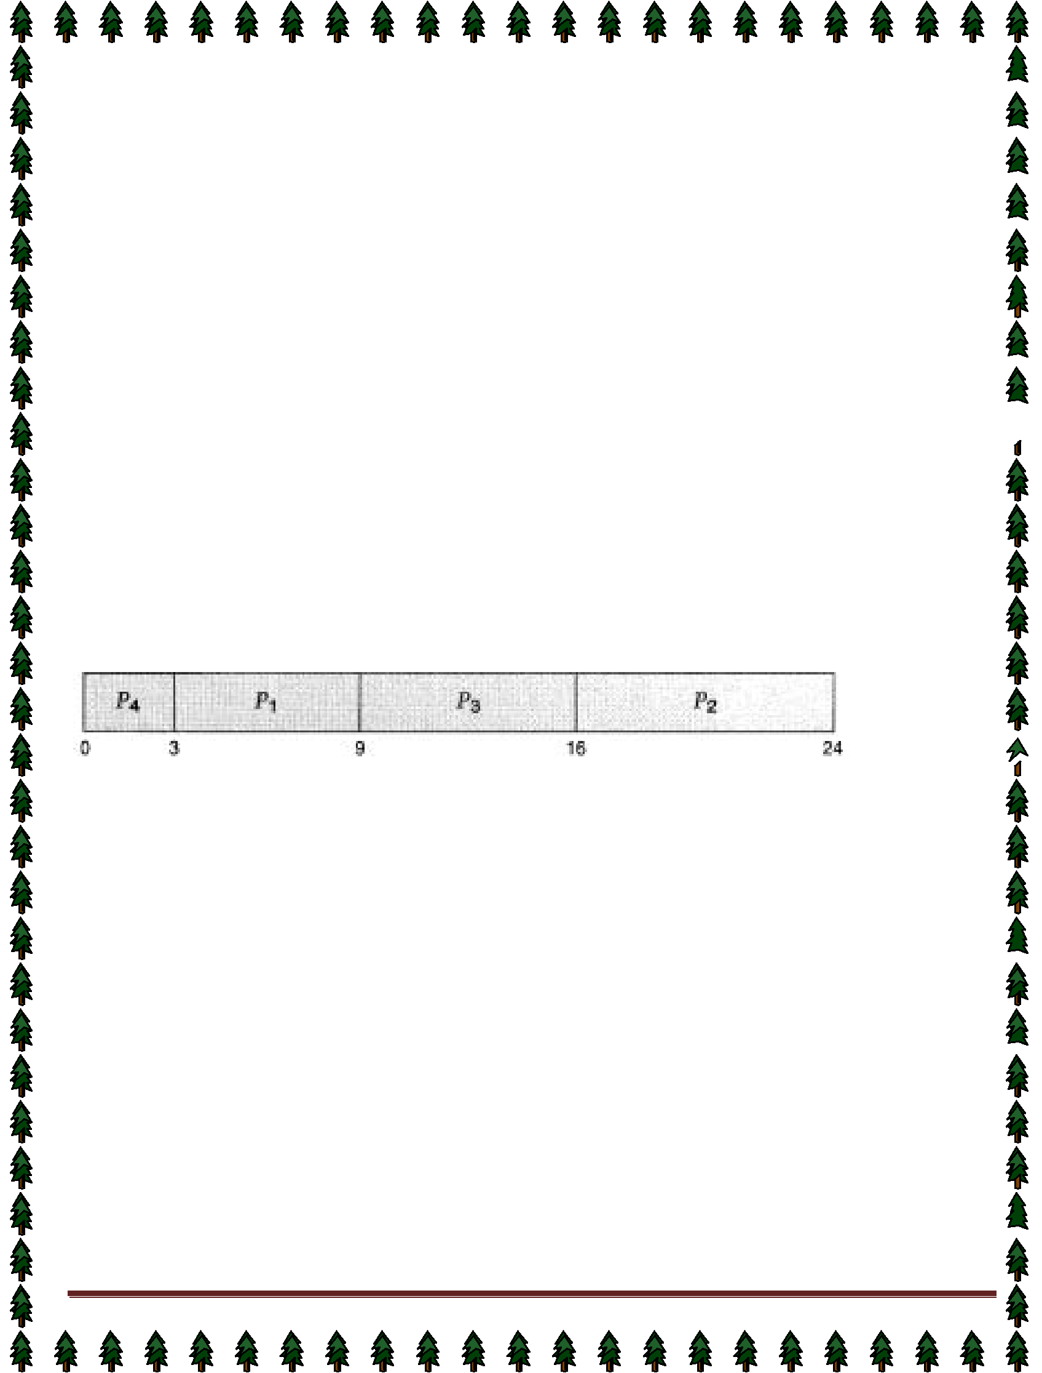
The CPU-bound process will then move back to the ready queue and be allocated the CPU. Again, all
the I/O processes end up waiting in the ready queue until the CPU-bound process is done. There is a convoy
effect, as all the other processes wait for the one big process to get off the CPU. This effect results in lower CPU
and device utilization than might be possible if the shorter processes were allowed to go first.

The FCFS scheduling algorithm is non-preemptive. Once the CPU has been allocated to a process, that process keeps the CPU until it releases the CPU, either by terminating or by requesting I/O. The FCFS algorithm is particularly troublesome for time-sharing systems, where each user needs to get a share of the CPU at regular intervals. It would be disastrous to allow one process to keep the CPU for an extended period.

Shortest-Job-First Scheduling

A different approach to CPU scheduling is the shortest-job-first (SJF) scheduling algorithm. This algorithm
associates with each process the length of the latter's next CPU burst. When the CPU is available, it is assigned
to the process that has the smallest next CPU burst. If two processes have the same length next CPU burst,
FCFS scheduling is used to break the tie. Note that a more appropriate term would be the shortest next CPU
burst, because the scheduling is done by examining the length of the next CPU burst of a process, rather than its

total length. We use the term SJF because most people and textbooks refer to this type of scheduling discipline
as SJF.

As an example, consider the following set of processes, with the length of the CPU-burst time given in milliseconds:
Process | Burst Time
PI | 6
p2 | 8
p3 | 7
p4 | 3

Using SJF scheduling, we would schedule these processes according to the following Gantt chart:

The waiting time is 3 milliseconds for process PI, 16 milliseconds for process P2,9 milliseconds for process PS,  and 0 milliseconds for process Pq. Thus, the average waiting time is (3 + 16 + 9 + 0)/4 = 7 milliseconds. If we were using the FCFS scheduling scheme, then the average waiting time would be 10.25 milliseconds.

The SJF scheduling algorithm is provably optimal, in that it gives the minimum average waiting time for a given set of processes. By moving a short process before a long one, the waiting time of the short process decreases more than it increases the waiting time of the long process. Consequently, the average waiting time decreases.

The real difficulty with the SJF algorithm is knowing the length of the next CPU request. For long-term (or job) scheduling in a batch system, we can use as the length the process time limit that a user specifies when he submits the job.

Thus, users are motivated to estimate the process time limit accurately, since a lower value may mean faster response. (Too low a value will cause a time-limit exceeded error and require resubmission.) SJF

scheduling is used frequently in long-term scheduling.
Although the SJF algorithm is optimal, it cannot be implemented at the level of short-term CPU scheduling. There is no way to know the length of the next CPU burst. One approach is to try to approximate SJF scheduling. We may not know the length of the next CPU burst, but we may be able to predict its value.We expect that the next CPU burst will be similar in length to the previous ones.

Thus, by computing an approximation of the length of the next CPU burst, we can pick the process with the shortest predicted CPU burst.

The SJF algorithm may be either preemptive or nonpreemptive. The choice arises when a new process arrives at the ready queue while a previous process is executing. The new process may have a shorter next CPU burst than what is left of the currently executing process. A preemptive SJF algorithm will preempt the currently executing process, whereas a nonpreemptive SJF algorithm will allow the currently running process to

finish its CPU burst. Preemptive SJF scheduling is sometimes called shortest-remaining-time-first scheduling. By Dr. Subhendu Kumar Rath, BPUT Page 20


As an example, consider the following four processes, with the length of the CPU-burst time given in milliseconds:

Process | Arrival Time | Burst Time
P1 | 0 | 8
P2 | 1 | 4
P3 | 2 | 9
p4 | 3 | 5
If the processes arrive at the ready queue at the times shown and need the indicated burst times, then the resulting preemptive SJF schedule is as depicted in the following Gantt chart:
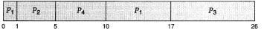

Process PI is started at time 0, since it is the only process in the queue. Process PZ arrives at time 1.  The remaining time for process P1 (7 milliseconds) is larger than the time required by process P2 (4 milliseconds), so process P1 is preempted, and process P2 is scheduled. The average waiting time for this example is ((10 - 1) + (1 - 1) + (17 - 2) + (5 - 3))/4 = 26/4 = 6.5 milliseconds. A nonpreemptive SJF scheduling would result in an average waiting time of 7.75 milliseconds.

Priority Scheduling

The SJF algorithm is a special case of the general priority-scheduling algorithm. A priority is associated with each process, and the CPU is allocated to the process with the highest priority. Equal-priority processes are scheduled in FCFS order.

An SJF algorithm is simply a priority algorithm where the priority (p) is the inverse of the (predicted) next CPU burst. The larger the CPU burst, the lower the priority, and vice versa.

Note that we discuss scheduling in terms of high priority and low priority. Priorities are generally some fixed range of numbers, such as 0 to 7, or 0 to 4,095. However, there is no general agreement on whether 0 is the highest or lowest priority. Some systems use low numbers to represent low priority; others use low numbers for high priority. This difference can lead to confusion. In this text, we use low numbers to represent high priority. As an example, consider the following set of processes, assumed to have arrived at time 0, in the order PI, P2,
..., Ps, with the length of the CPU-burst time given in milliseconds:

Process | Burst | Time Priority
P1 | 10 | 3
p2 | 1 | 1
p3 | 2 | 4
P4 | 1 | 5
P5 | 5 | 2
Using priority scheduling, we would schedule these processes according to the following Gantt chart:
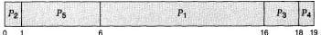

The average waiting time is 8.2 milliseconds. Priorities can be defined either internally or externally.  Internally defined priorities use some measurable quantity or quantities to compute the priority of a process.

For example, time limits, memory requirements, the number of open files, and the ratio of average I/O burst to average CPU burst have been used in computing priorities. External priorities are set by criteria that are external to the operating system, such as the importance of the process, the type and amount of funds being paid for computer use, the department sponsoring the work, and other, often political, factors.

Priority scheduling can be either preemptive or nonpreemptive. When a process arrives at the ready queue, its priority is compared with the priority of the currently running process. A preemptive priority-scheduling algorithm will preempt the CPU if the priority of the newly arrived process is higher than the priority of the currently running process. A nonpreemptive priority-scheduling algorithm will simply put the new process at the head of the ready queue.

A major problem with priority-scheduling algorithms is indefinite blocking (or starvation). A process that is
ready to run but lacking the CPU can be considered blocked-waiting for the CPU. A priority-scheduling algorithm
By Dr. Subhendu Kumar Rath, BPUT | Page 21
can leave some low-priority processes waiting indefinitely for the CPU.


A solution to the problem of indefinite blockage of low- priority processes is aging. Aging is a technique of gradually increasing the priority of processes that wait in the system for a long time. For example, if priorities range from 127 (low) to 0 (high), we could decrement the priority of a waiting process by 1 every 15 minutes.

Eventually, even a process with an initial priority of 127 would have the highest priority in the system and would be executed. In fact, it would take no more than 32 hours for a priority 127 process to age to a priority 0 process.

Round-Robin Scheduling

The round-robin (RR) scheduling algorithm is designed especially for timesharing systems. It is similar to FCFS scheduling, but preemption is added to switch between processes. A small unit of time, called a time quantum (or time slice), is defined. A time quantum is generally from 10 to 100 milliseconds. The ready queue is treated as a circular queue. The CPU scheduler goes around the ready queue, allocating the CPU to each process for a time interval of up to 1 time quantum.
To implement RR scheduling, we keep the ready queue as a FIFO queue of processes. New processes
are added to the tail of the ready queue. The CPU scheduler picks the first process from the ready queue, sets a
timer to interrupt after 1 time quantum, and dispatches the process.
One of two things will then happen. The process may have a CPU burst of less than 1 time quantum. In

this case, the process itself will release the CPU voluntarily. The scheduler will then proceed to the next process
in the ready queue. Otherwise, if the CPU burst of the currently running process is longer than 1 time quantum,
the timer will go off and will cause an interrupt to the operating system. A context switch will be executed, and
the process will be put at the tail of the ready queue. The CPU scheduler will then select the next process in the
ready queue.

The average waiting time under the RR policy, however, is often quite long.

Consider the following set of processes that arrive at time 0, with the length of the CPU-burst time given
in milliseconds:
Process | Burst Time
PI | 24
P2 | 3
P3 | 3
If we use a time quantum of 4 milliseconds, then process P1 gets the first 4 milliseconds. Since it requires another 20 milliseconds, it is preempted after the first time quantum, and the CPU is given to the next process in the queue, process P2. Since process P2 does not need 4 milliseconds, it quits before its time quantum expires. The CPU is then given to the next process, process P3. Once each process has received 1 time quantum, the CPU is returned to process P1 for an additional time quantum. The resulting RR schedule is 

The average waiting time is 17/3 = 5.66 milliseconds.
In the RR scheduling algorithm, no process is allocated the CPU for more than 1 time quantum in a row.
If a process' CPU burst exceeds 1 time quantum, that process is preempted and is put back in the ready queue.
The RR scheduling algorithm is preemptive.

If there are n processes in the ready queue and the time quantum is q, then each process gets l/n of the
CPU time in chunks of at most q time units. Each process must wait no longer than (n - 1) x q time units until its
next time quantum. For example, if there are five processes, with a time quantum of 20 milliseconds, then each
process will get up to 20 milliseconds every 100

milliseconds. The performance of the RR algorithm depends heavily on the size of the time quantum. At one extreme,

if the time quantum is very large (infinite), the RR policy is the same as the FCFS policy. If the time quantum is very small (say 1 microsecond), the RR approach is called processor sharing, and appears (in theory) to the users as though each of n processes has its own processor running at l/n the speed of the real processor. This approach was used in Control Data Corporation (CDC) hardware to implement 10 peripheral processors with only one set of hardware and 10 sets of registers. The hardware executes one instruction for one set of registers, then goes on to the next. This cycle continues, resulting in 10 slow processors rather than one fast processor.

Multilevel Queue Scheduling

Another class of scheduling algorithms has been created for situations in which processes are easily
classified into different groups. For example, a common division is made between foreground (or interactive) By Dr. Subhendu Kumar Rath, BPUT Page 22


processes and background (or batch) processes. These two types of processes have different response-time requirements, and so might have different scheduling needs. In addition, foreground processes may have priority (or externally defined) over background processes.

Preemptive Vs Nonpreemptive Scheduling

The Scheduling algorithms can be divided into two categories with respect to how they deal with clock  interrupts.

Nonpreemptive Scheduling: A scheduling discipline is nonpreemptive , if once a process has been used the CPU, the CPU cannot be taken away from that process.

Preemptive Scheduling: A scheduling discipline is preemptive, if once a process has been used the CPU, the CPU can taken away.

By Dr. Subhendu Kumar Rath, BPUT Page 23


Lecture #13,#14

Thread

A thread, sometimes called a lightweight process (LWP), is a basic unit of CPU utilization; it comprises a thread ID, a program counter, a register set, and a stack. It shares with other threads belonging to the same process its code section, data section, and other operating-system resources, such as open files and signals. A traditional (or heavyweight) process has a single thread of control. If the process has multiple threads of control, it can do more than one task at a time.

Motivation

Many software packages that run on modern desktop PCs are multithreaded.An application typically is implemented as a separate process with several thread of control.

Single -threaded and multithreaded
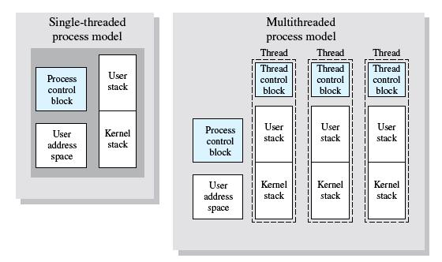

Ex: A web browser might have one thread display images or text while another thread retrieves data  from the network. A word processor may have a thread for displaying graphics, another thread for reading keystrokes from the user, and a third thread for performing spelling and grammar checking in the background.

In certain situations a single application may be required to perform several similar tasks. For example, a web server accepts client requests for web pages, images, sound, and so forth. A busy web server may have several (perhaps hundreds) of clients concurrently accessing it. If the web server ran as a traditional single- threaded process, it would be able to service only one client at a time.

One solution is to have the server run as a single process that accepts requests. When the server

receives a request, it creates a separate process to service that request. In fact, this process-creation method
was in common use before threads became popular. Process creation is very heavyweight, as was shown in the

previous chapter. If the new process will perform the same tasks as the existing process, why incur all that
overhead? It is generally more efficient for one process that contains multiple threads to serve the same
purpose. This approach would multithread the web-server process. The server would create a separate thread
that would listen for client requests; when a request was made, rather than creating another process, it would
create another thread to service the request.
Threads also play a vital role in remote procedure call (RPC) systems. RPCs allow inter-process communication by providing a communication mechanism similar to ordinary function or procedure calls. Typically, RPC servers are multithreaded. When a server receives a message, it services the message using a separate thread. This allows the server to service several concurrent requests.

Benefits

The benefits of multithreaded programming can be broken down into four major categories:
- Responsiveness: Multithreading an interactive application may allow a program to continue running even if part of it is blocked or is performing a lengthy operation, thereby increasing responsiveness to the user. For
instance, a multithreaded web browser could still allow user interaction | Page 24
By Dr. Subhendu Kumar Rath, BPUT | Page 24
in one thread while an image is being loaded in another thread.


- Resource sharing: By default, threads share the memory and the resources of the process to which they belong. The benefit of code sharing is that it allows an application to have several different threads of activity all within the same address space.
- Economy: Allocating memory and resources for process creation is costly. Alternatively, because threads share resources of the process to which they belong, it is more economical to create and context switch threads.

It can be difficult to gauge empirically the difference in overhead for creating and maintaining a process rather than a thread, but in general it is much more time consuming to create and manage processes than threads. In Solaris 2, creating a process is about 30 times slower than is creating a thread, and context switching is about five times slower.
- Utilization of multiprocessor architectures: The benefits of multithreading can be greatly increased in a multiprocessor architecture, where each thread may be running in parallel on a different processor. A single-threaded process can only run on one CPU, no matter how many are available.
Multithreading on a multi-CPU machine increases concurrency. In a single processor architecture, the CPU generally moves between each thread so quickly as to create an illusion of parallelism, but in reality only

one thread is running at a time.
The OS supports the threads that can provided in following two levels:

User-Level Threads User-level threads implement in user-level libraries, rather than via systems calls, so thread switching

does not need to call operating system and to cause interrupt to the kernel. In fact, the kernel knows nothing about user-level threads and manages them as if they were single-threaded processes.

Advantages:

- User-level threads do not require modification to operating systems.
- Simple Representation: Each thread is represented simply by a PC, registers, stack and a small control block, all stored in the user process address space.

- Simple Management: This simply means that creating a thread, switching between threads and synchronization between threads can all be done without intervention of the kernel.
- Fast and Efficient: Thread switching is not much more expensive than a procedure call.

Disadvantages:

- There is a lack of coordination between threads and operating system kernel.
- User-level threads require non-blocking systems call i.e., a multithreaded kernel.
Kernel-Level Threads
In this method, the kernel knows about and manages the threads. Instead of thread table in each process, the

kernel has a thread table that keeps track of all threads in the system. Operating Systems kernel provides

system call to create and manage threads.
Advantages:

- Because kernel has full knowledge of all threads, Scheduler may decide to give more time to a process having large number of threads than process having small number of threads.
Kernel-level threads are especially good for applications that frequently block.
Disadvantages:

The kernel-level threads are slow and inefficient. For instance, threads operations are hundreds of times slower than that of user-level threads.

Since kernel must manage and schedule threads as well as processes. It require a full thread control block (TCB) for each thread to maintain information about threads. As a result there is significant overhead and increased in kernel complexity.

Multithreading Models

Many systems provide support for both user and kernel threads, resulting in different multithreading models. We look at three common types of threading implementation.

Many-to-One Model

The many-to-one model maps many user- level threads to one kernel thread. Thread management is done in user space, so it is efficient, but the entire process will block if a thread makes a blocking system call. Also, because only one thread can access the kernel at a time, multiple threads are unable to run in parallel on
multiprocessors.
One-to -one Model | Page 25

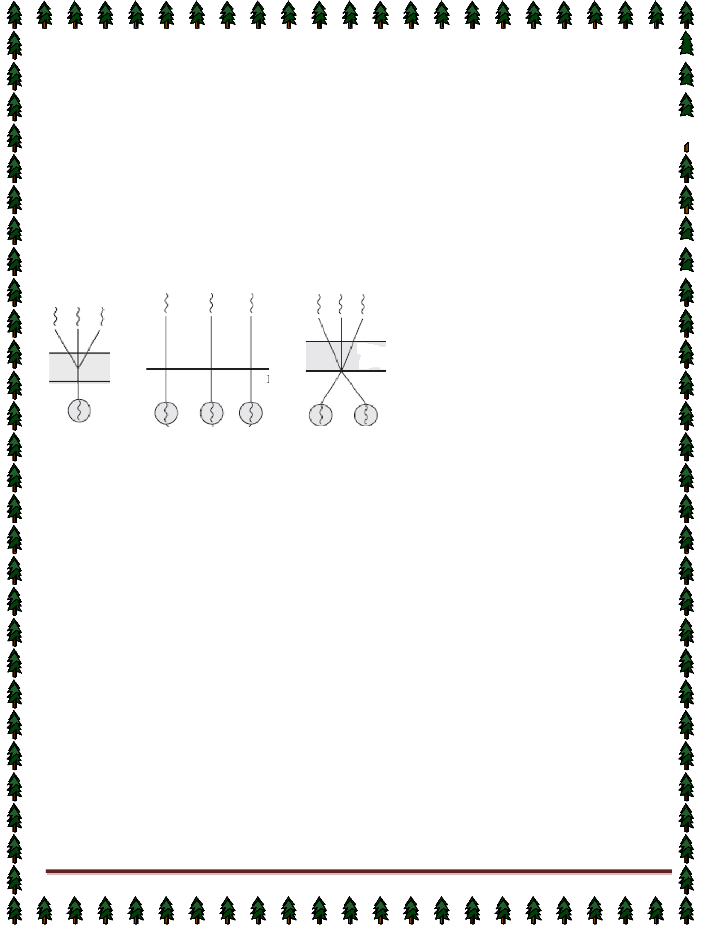
The one-to- one model maps each user thread to a kernel thread. It provides more concurrency than the many-to-one model by allowing another thread to run when a thread makes a blocking system call; it also allows multiple threads to run in parallel on multiprocessors. The only drawback to this model is that creating a user thread requires creating the corresponding kernel thread. Because the overhead of creating kernel threads can burden the performance of an application, most implementations of this model restrict the number of threads supported by the system. Windows NT, Windows 2000, and OS/2 implement the one-to-one model.

Many-to-Many Model  The many-to-many model multiplexes many user-level threads to a smaller or equal number of kernel

threads. The number of kernel threads may be specific to either a particular application or a particular machine (an application may be allocated more kernel threads on a multiprocessor than on a uniprocessor). Whereas the many-to-one model allows the developer to create as many user threads as she wishes, true concurrency is not gained because the kernel can schedule only one thread at a time. The one-to- one model allows for greater concurrency, but the developer has to be careful not to create too many threads within an application (and in some instances may be limited in the number of threads she can create). The many-to-many model suffers from neither of these shortcomings: Developers can create as many user threads as n

